Food Webs – Understanding What Happened When Wolves Returned to Yellowstone

Wolves in Yellowstone National Park
In the early twentieth century, humans eliminated wolves from Yellowstone. In the late twentieth century, humans brought wolves back to Yellowstone. How did these changes in the wolf population affect the other animals and plants in Yellowstone?

To begin to answer this question, watch the “Ecosystems Video” (https://www.learner.org/series/the-habitable-planet-a-systems-approach-to-environmental-science/ecosystems/ecosystems-video/), beginning at 13 minutes and 40 seconds and ending at 22 minutes and 37 seconds. An ecosystem includes the animals, plants and other organisms in an area and their physical environment.

These graphs summarize recent trends in the numbers of wolves and elk in the Northern Range in Yellowstone.
1a. Why did the number of elk decrease after 1995?  1b. What happened to the bodies of the thousands of dead elk? | 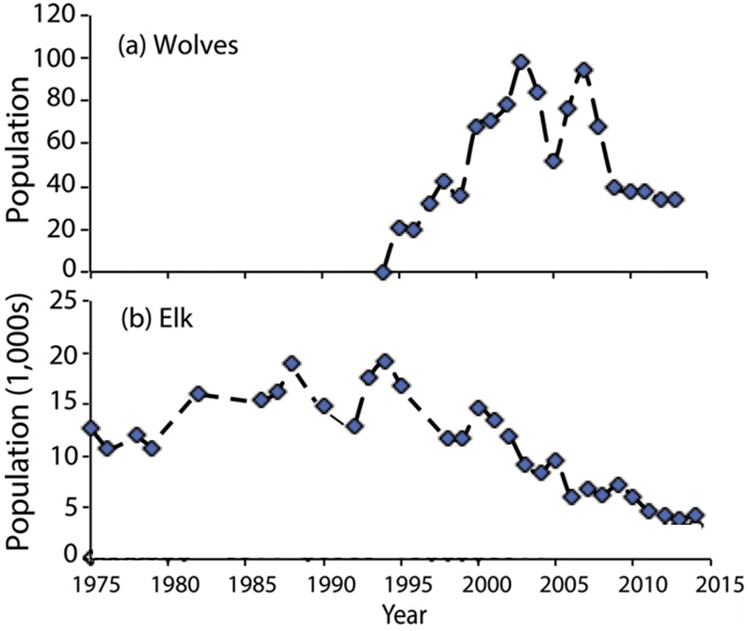

2. After 1995, willows grew taller in some parts of Yellowstone. What is one possible explanation for this trend?

3a. Beavers use tall willows for food and building dams. Predict the change in the number of beavers when wolves returned to Yellowstone Park. decreased ___ increased ___

3b. Explain your reasoning.

We will return to these questions after you have learned about food chains and food webs.

Food Chains and Food Webs

This figure shows a food chain. Secondary consumers eat primary consumers which eat producers (plants).

Notice that producers are shown at the bottom of the food chain. Each level above that eats organisms from the level below.

A food chain summarizes a sequence of trophic relationships, where trophic means eating or nutrition.

4. Write mountain lion, grass, and rabbit in the appropriate blank boxes to show a food chain.

There is another type of food chain that doesn’t begin with living plants.

5. Think about a 100-year-old forest where the leaves have dropped from the trees each fall, dead branches have fallen, and animals have died each year. You won’t see 100 years of dead stuff piled up on the ground in the forest. What has happened to all the dead stuff?

Decomposers get their nutrition from dead organic matter. Decomposers include bacteria and fungi (e.g. mushrooms) which secrete digestive enzymes and absorb digested molecules from the dead organic matter.

The first flowchart on the right shows a food chain with decomposers, and the second flowchart shows an example from Yellowstone.  6. If you visited Yellowstone, you would not notice this food chain. Why not? | 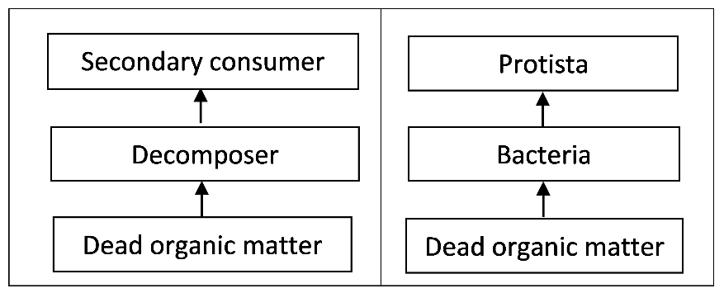

7. Match each item in the top list with the best match or matches from the bottom list.

Producer ___
Primary consumer ___ ___
Secondary consumer ___ ___

- an animal that eats plants
- an organism that consumes primary consumers
- an organism that consumes producers
- an organism that makes its own organic molecules from small inorganic molecules (e.g. uses photosynthesis to make sugars from CO₂ and H₂O)
- includes some predators and Protista
In real biological communities, the trophic relationships are much more complex than a simple food chain. These more complex trophic relationships are summarized in a food web.

This figure shows a small part of a food web. Notice that the food web contains multiple food chains.

8. Use asterisks (*) to mark the organisms in one food chain in this food web.

Most of the organisms in this food web can be classified in one of these trophic levels:
- producers
- primary consumers
- secondary consumers.
However, not all organisms fit in a single trophic level. You may have heard of omnivores which eat both plants and animals. A more general category is a trophic omnivore which is any animal that eats organisms from more than one trophic level.

9. In the above figure, use one of the following symbols to label each type of organism.
P = Producer (There are 2 of them.)
PC = Primary Consumer (3)
SC = Secondary Consumer (2)
TO = Trophic Omnivore (3; any animal that eats trophic omnivores is a trophic omnivore.)

Trophic Relationships in Yellowstone
In the procedure below, complete each step and check the box before beginning the next step.

- Pages 4-7 show some of the organisms that live in Yellowstone National Park. Find the producers and write their names in the appropriate blanks in the chart below.
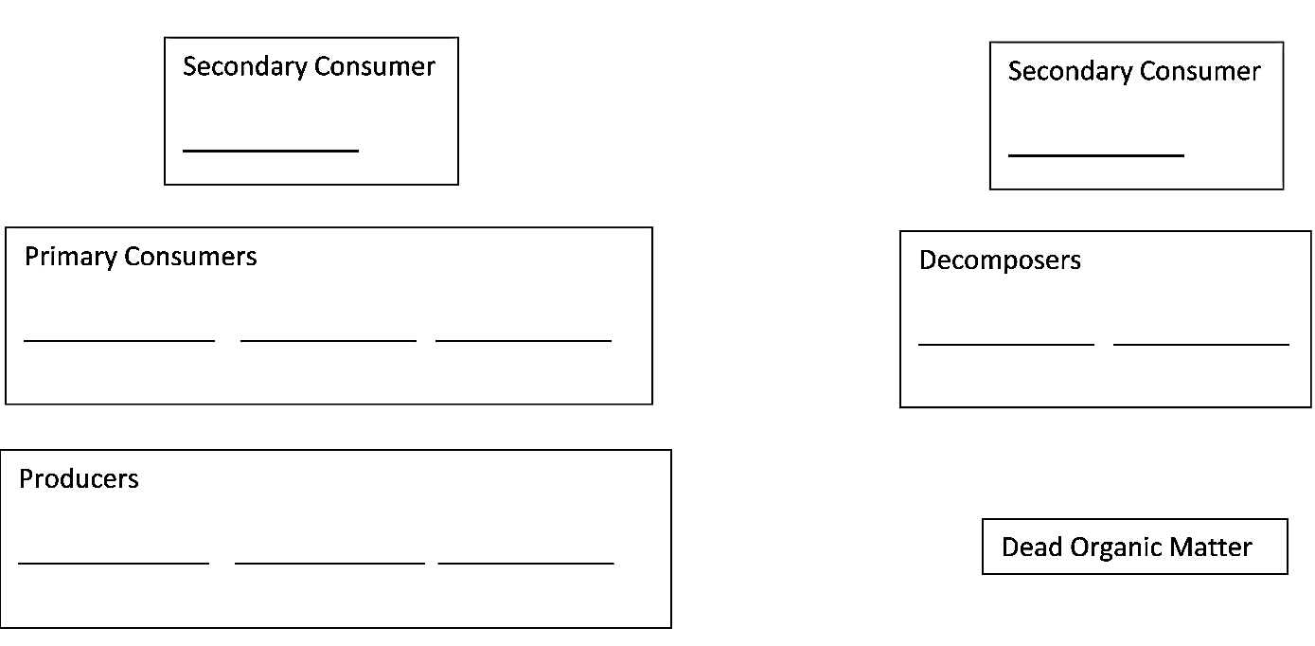

- Find the primary consumers (which eat only producers) and the decomposers (which consume only dead organic matter). Write their names on the blanks in the rectangles for primary consumers and decomposers. Draw an arrow to show each trophic relationship described on the cards.
- Fill in the blanks for the secondary consumers and write the names of the trophic omnivores in appropriate places outside the rectangles. (Any animal that eats trophic omnivores is also a trophic omnivore. Yellowstone wolves are trophic omnivores, since they eat coyotes as well as primary consumers.) Draw an arrow to show each trophic relationship described on the cards.

Your Yellowstone food web may look complex, but a complete Yellowstone food web would be much more complex.
- Many more types of organisms live in Yellowstone, including more than 1000 different kinds of plants and more than 1000 different kinds of insects.
- The trophic relationships are more complex than is shown in your food web. For example, when an elk is killed by a pack of wolves, the wolves eat much of the meat, but other animals such as bears, coyotes and ravens eat some of the rest, and parts of the elk become dead organic matter which is consumed by decomposers.
- Some of the trophic relationships shown are much more important than others. For example, Yellowstone wolves eat many elk and few beavers.
10a. Make the arrow from elk to wolves fatter to represent the importance of this trophic relationship.

10b. Draw arrows from the primary consumers and producers to dead organic matter. These arrows will represent the general point that all or parts of many plants and animals become dead organic matter which is consumed by decomposers.

Even though your food web is incomplete, it can help you to predict and understand important ecological phenomena.

A trophic cascade occurs when a change in the population of a predator not only affects its prey population, but also has indirect effects on another population in the ecosystem. In this flowchart, each arrow represents a negative effect of one population on the size of another population.

11. Add a curved arrow with a (+) to show the indirect effect of wolves on the willow population in this trophic cascade.

12. Explain how changes in the wolf population could produce the following trends in the number of beaver colonies.
- After wolves were eliminated from Yellowstone, the number of beaver colonies decreased.
- After wolves were reintroduced to Yellowstone, the number of beaver colonies increased.
(Hint: Beavers use tall willows for food and building dams.)

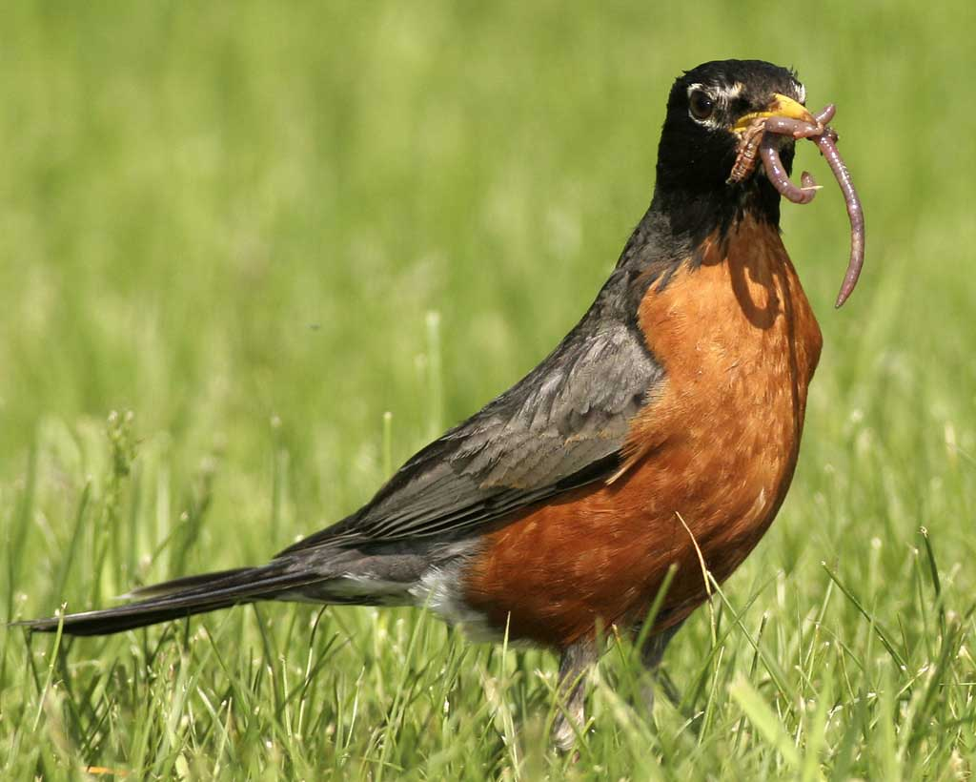  23-28 cm  American Robins  Eat: Earthworms, beetles,  other flowering plants  Eaten by: Snakes and  birds of prey (not  included in this food web) | 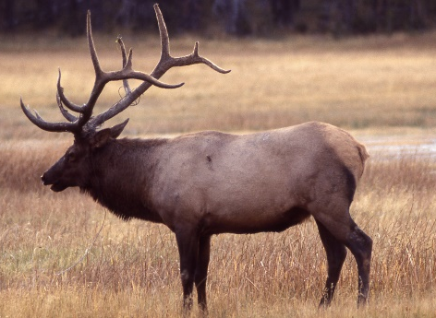  2.1-2.4 m  Elk  Eat: Grasses, willows,  other flowering  plants  Eaten by: Gray wolves,  grizzly bears, coyotes | 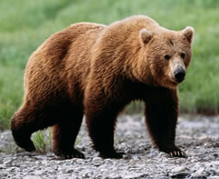  1.8-3.3 m  Grizzly Bears  Eat: Other flowering  plants (including  berries), elk
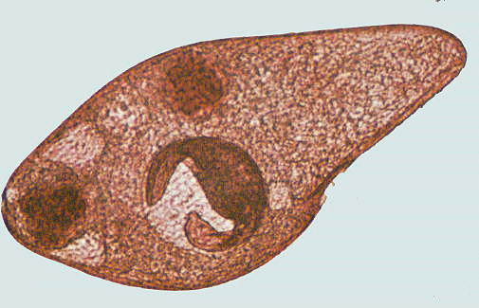  <1 mm  Protista  Eat: Bacteria  Eaten by: Nematodes | 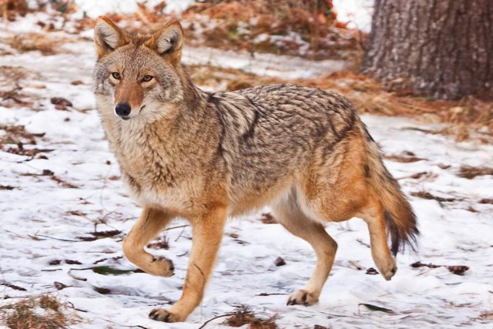  1-1.4 m  Coyotes  Eat: deer mice, elk  Eaten by: Gray wolves | 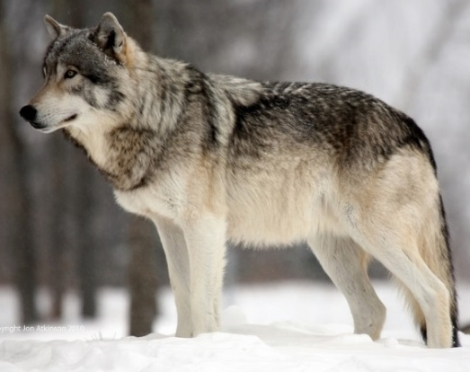  1.4-2 m  Gray Wolves  Eat: Elk, coyotes, beavers

<80-400 cm  Willows  Eaten by: Elk, beavers | Grasses (including seeds)  Eaten by: Elk, deer mice | Dead Organic Matter  Consumed by: Bacteria,  fungi, earthworms
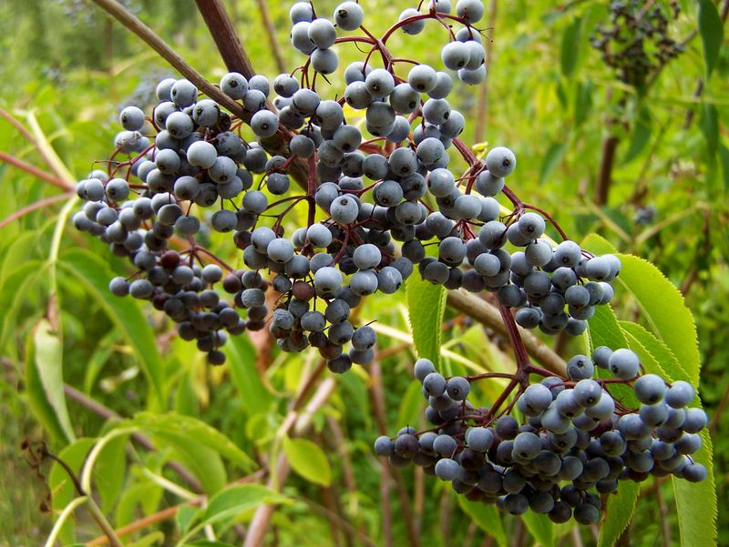  Other flowering plants  (including berries)  Eaten by: American  robins, deer mice,  elk, grizzly bears | 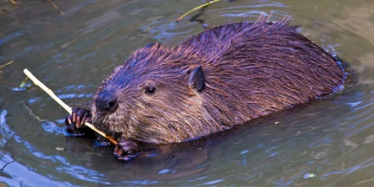58-99 cm (length, excluding tail)  Beavers  Eat: Willows  Eaten by: Gray wolves | 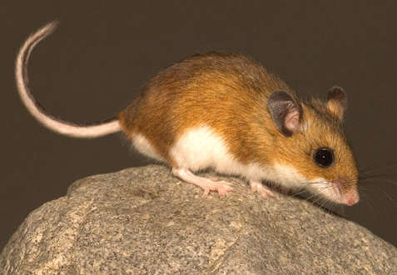  8-10 cm (length, excluding tail)  Deer Mice  Eat: Grasses; other  flowering plants  Eaten by: Coyotes

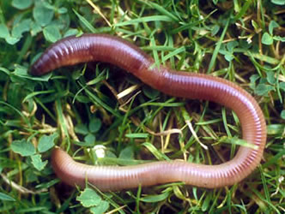  7-35 cm  Earthworms  Eat: Dead organic matter,  fungi, bacteria  Eaten by: American robins | 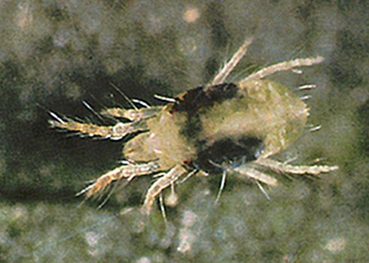  0.5-1 mm  Mites  Eat: Nematodes, fungi  Eaten by: Beetles | 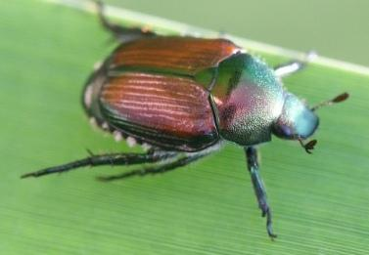  5-20 mm  Beetles  Eat: Mites  Eaten by: American  robins
Fungi  Consume: Dead organic  matter  Eaten by: Earthworms,  mites, nematodes, | 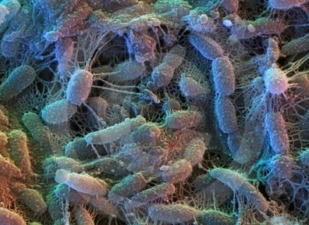  2-6 µm  Bacteria  Consume: Dead organic  matter  Eaten by: Protista,  nematodes,  earthworms | 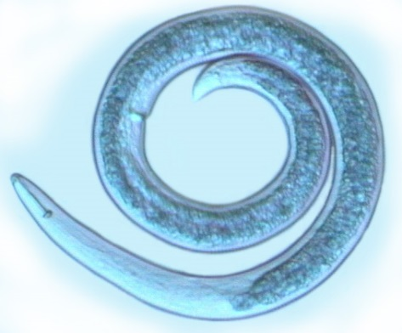  0.1-2.5 mm  Nematodes  Eat: Protista, fungi,  bacteria  Eaten by: Mites

By Drs. Ingrid Waldron and Lori Spindler, Dept Biology, University of Pennsylvania. © 2021. This Student Handout, an alternative version of the Student Handout for students who are learning at home and have a printer or are learning in the classroom, and the Teacher Preparation Notes with instructional suggestions and background information are available at https://serendipstudio.org/sci_edu/waldron/#foodweb.

